Student’s name | …………………………………………………….…… | Grade | 3
Subject | Computer | Week No. | 6
Lesson Title | Hello Scratch | Unit
Worksheet No. ( 6 ) (Answer)

Instruction: Color the parts of computer.

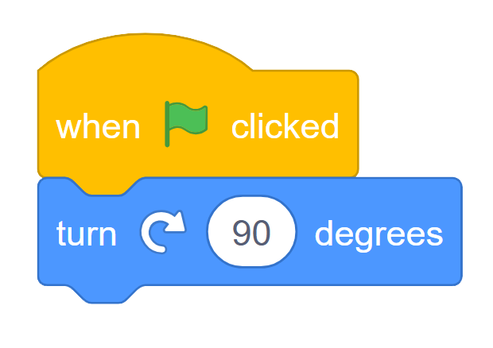

Good Luck

